Arduino wakeup light documentation

By Yubo Qiu

August 9, 2015

This functional specification will be available in PDF format for those who don’t have/use Word.

# Change Log

|  |  |  |
| --- | --- | --- |
| Author | Date | Notes |
| Yubo Qiu | Aug 9, 2015 | Initial Draft |
|  |  |  |
|  |  |  |
|  |  |  |
|  |  |  |
|  |  |  |
|  |  |  |

Table of Contents

# Introduction

* 1. Purpose of this project

Wake-up lights are quite popular now, and ones that can be bought are quite expensive. I wanted a cheap solution, but felt that online DIY solutions were unpolished. None of the DIY solutions were intuitive, or they lacked things I would find useful, such as using the wake-up light as a smart light. Additionally, I felt that many core features were not included in DIY solutions; they felt hacked together and did not involve any creativity. So, I decided to make my own, and here it is.

* 1. Purpose of this document

This document is intended to describe functional specifications of the wake-up light. Since this project is relatively simple, both the hardware and software specifications will be found in this single document.

* 1. Scope of the project

The wakeup light provides a more peaceful way of waking up—rather than using an annoying buzzing noise to get up, it gradually increases the brightness of the LED strips to simulate a sunrise over a specified (default 30min) period. This provides a more natural way of waking up.

1. General Description
   1. Product Functions

This product features one rotary encoder that controls majority of the functions. The main function is to gradually turn up an LED strip over a specified period (default 30min). Other functions include a gradually dimming turn off, and can be used as an automatic on light.

* 1. D

1. Functional Requirements
   1. User Interface
      1. The user will use the one rotary encoder + button that is available to interface the LED clock.
   2. State machine
      1. Sleep State

By default the clock is in sleep state, where the LCD LED is off, and the clock and date is shown

* + 1. Awake State

When the dial is turned left/right or pressed, then the clock will enter awake state where the LCD LED will turn on.

* + 1. Menu state

The menu state will be displayed when the button is held for 3s. TO leave the menu state, hold the button for 3s, or navigate to exit.

* 1. Block diagram

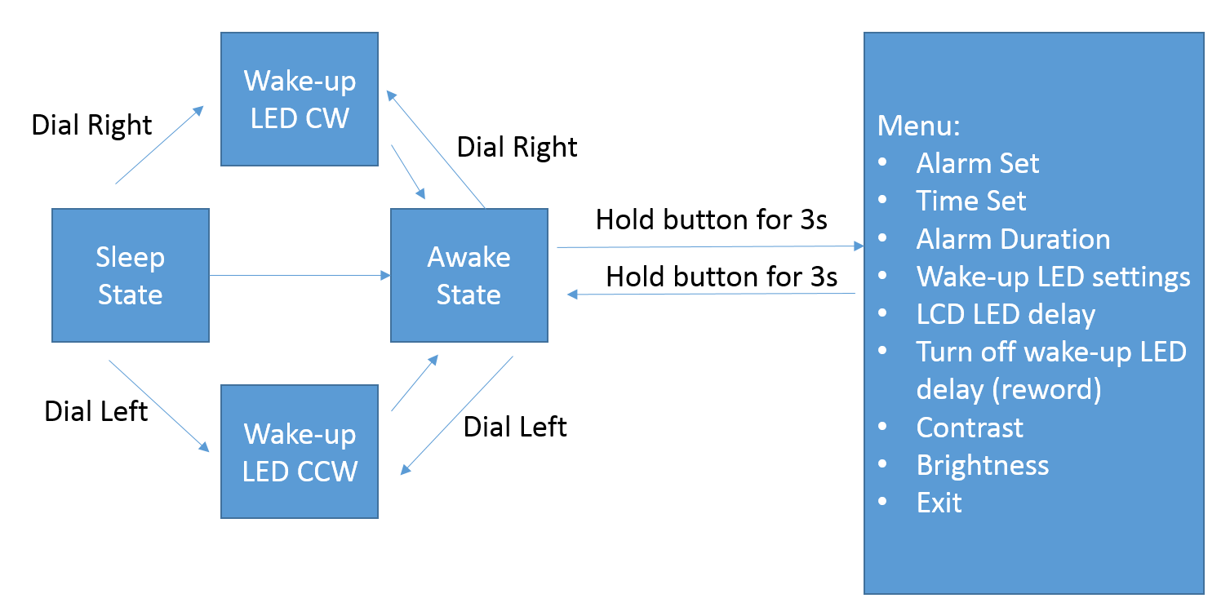

1. ToDo

Bluetooth integration for android/iOS

Remote control functionality

Add a python wrapper to really test out my coding skills!